LAB SESSION 4
Programming Exercise:
Question 1: Write a function swap that takes two integer pointers as arguments and swaps the values they point to.
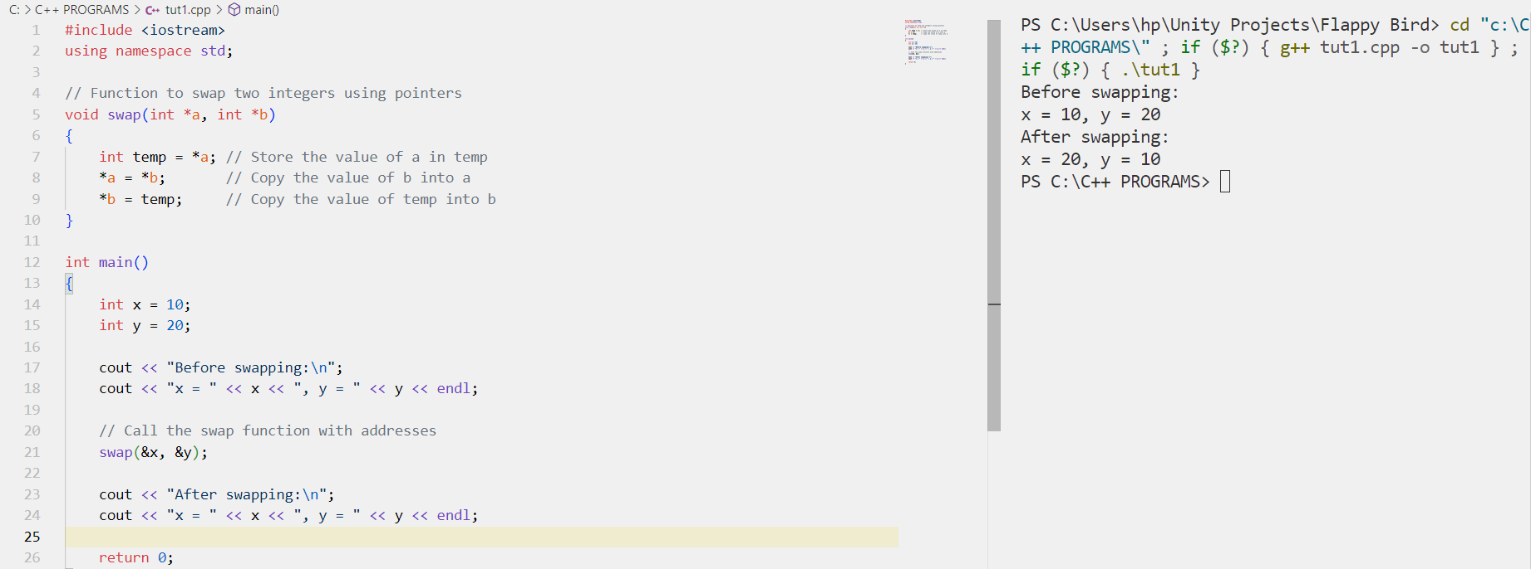

Question 2: Write a function reverse Array that takes an integer array and its size as arguments and reverses the elements of the array using pointers.
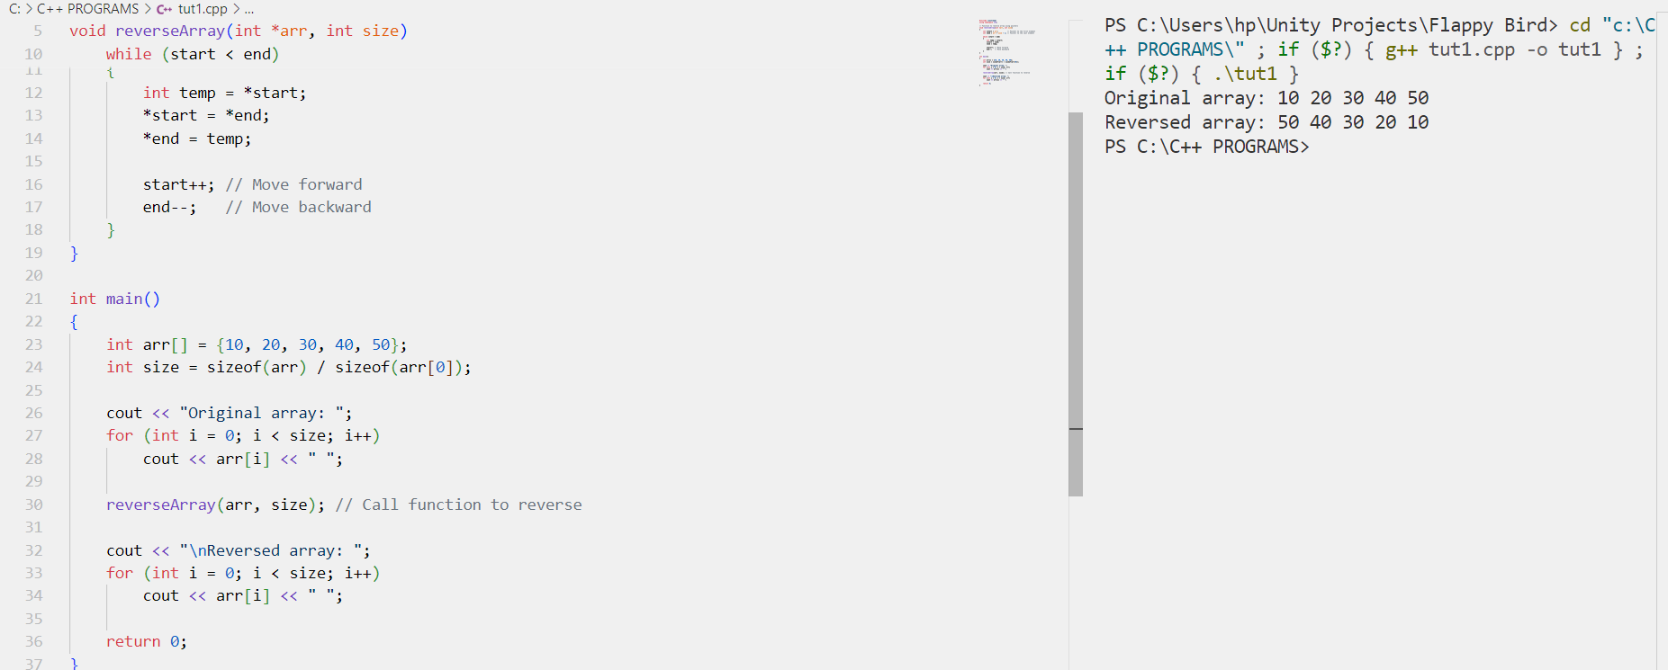

Question 3: Write function find Max that takes an integer array and its size as arguments and returns a pointer to the maximum element in the array.
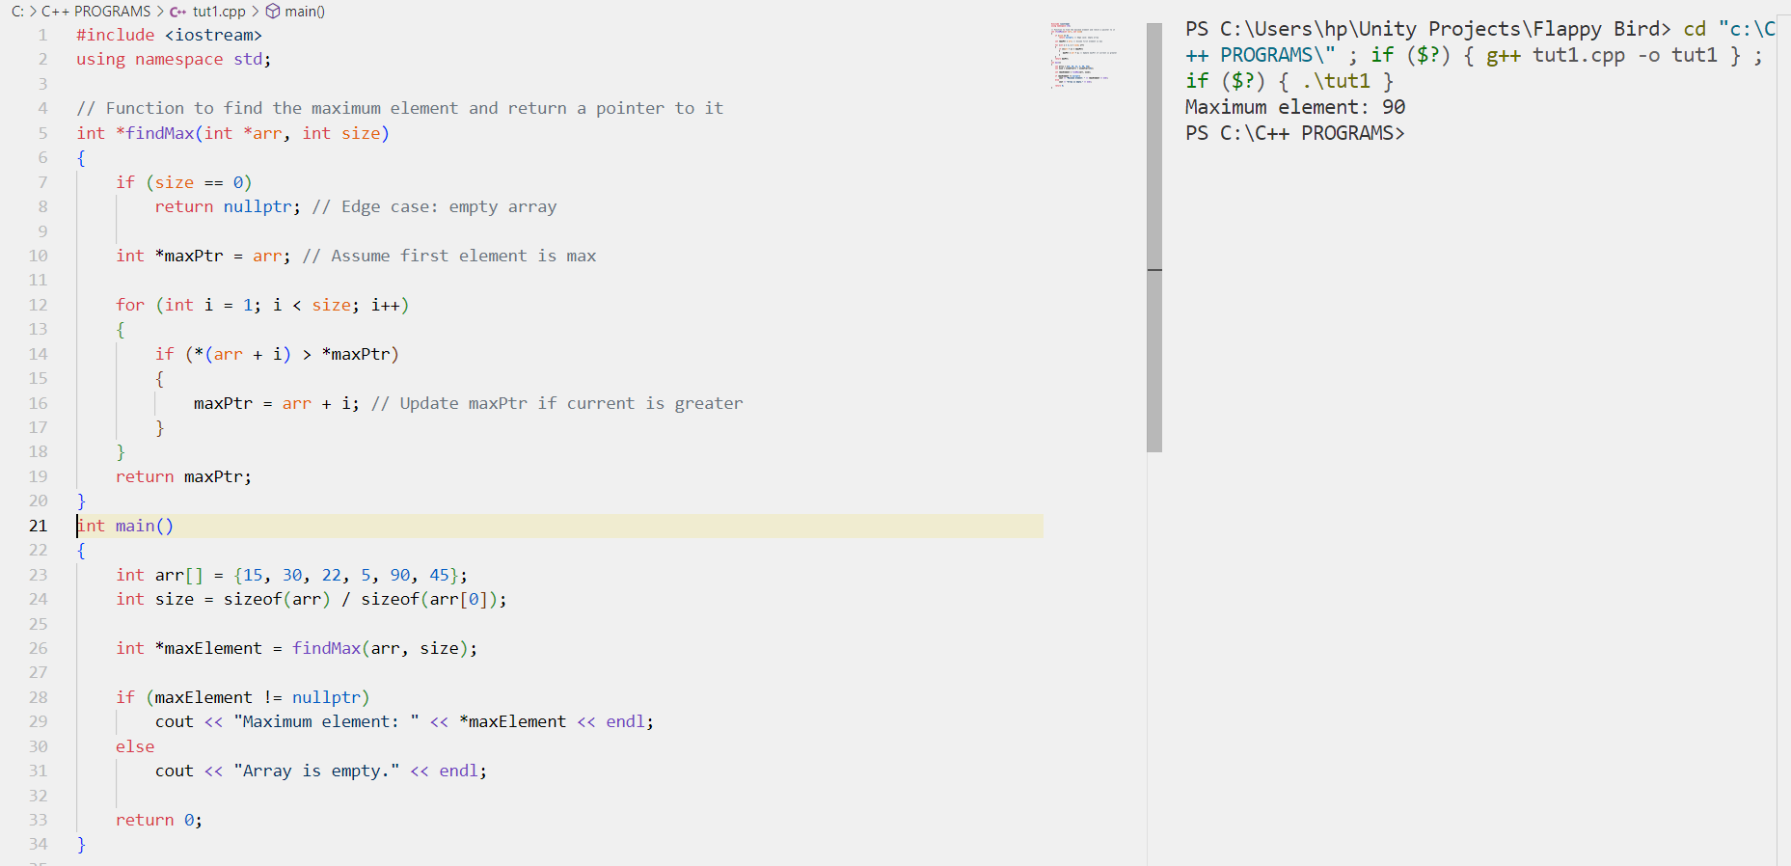

Question 4: Write a function remove Duplicates that takes an integer array and its size as arguments and removes duplicates, keeping only the first occurrence of each element.
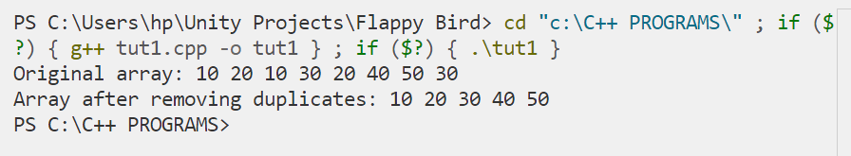
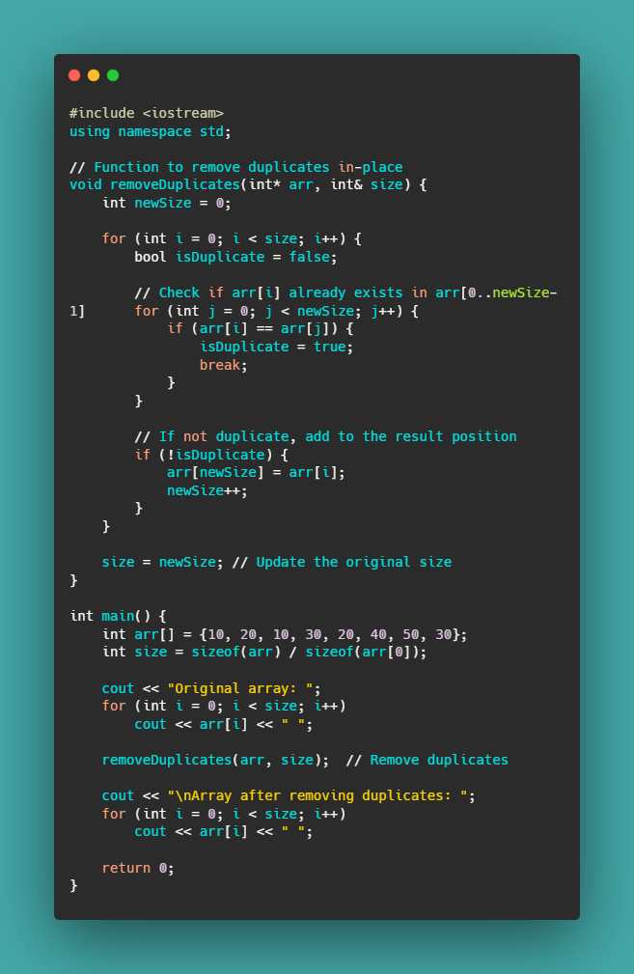
Question 5: Write a function isPalindrome that takes a string as an argument and returns true if the string is a palindrome, false otherwise. Use pointers to check for palindrome.
